**Python TRAINING**

**Python Assignment – 3**

**SHAFALI GUPTA**

1. **Create a program to do the following tasks:**
2. **Split a given Sentence into list of words**
3. **Sort that list according to the letters alphabetically.**
4. **Sort that list alphabetically**

Take string input from user:

Input: "i love to code in python"

Output A) ==> ['i','love','to','code','in','python']

Output B) ==> ['code','i,'in','love','python','to']

Output C) ==> ['cdeo','i','in','elov','hnopty','ot']

**Ans:-**

**A &B) See below Screenshot -**

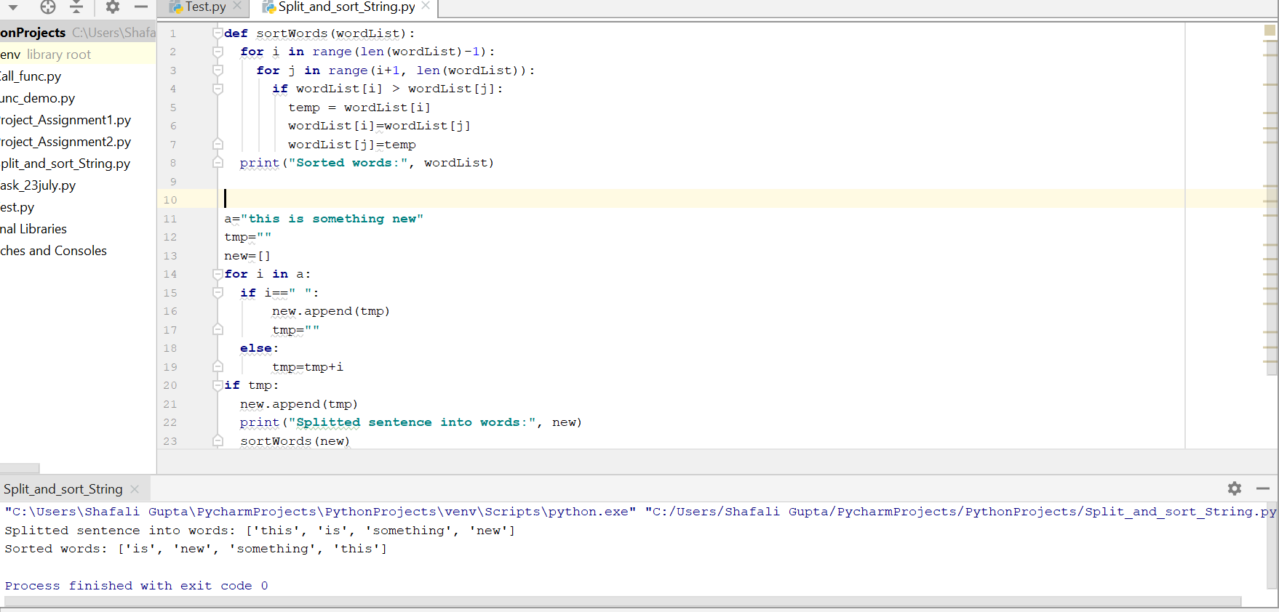

**2- Upload each and every task given till Friday over GitHub.**

**Ans:-** Uploaded on GitHub every python code file with document**.** Also attached screenshot below for each.

**3- Implement following sorting Algorithms Programmatically as well as theoretically:**

**A) Bubble Sort. B) Quick Sort. C) Selection Sort. D) Merge Sort.**

**Ans:- A) Bubble Sort:**

A simple sorting algorithm repeatedly steps through the list to be sorted, compares each pair of adjacent items and swaps them if they are in the wrong order. The pass through the list is repeated until no swaps are needed, which indicates that the list is sorted. For e.g. below is the list which is unordered.

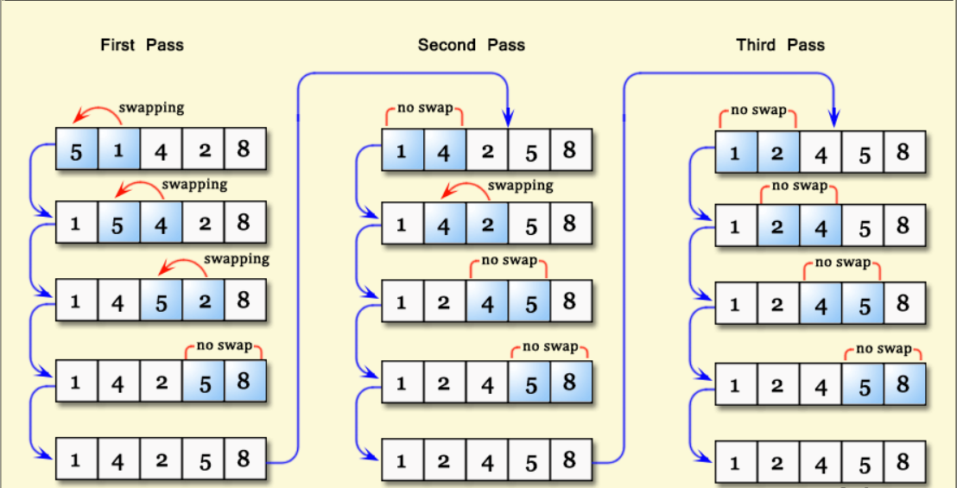

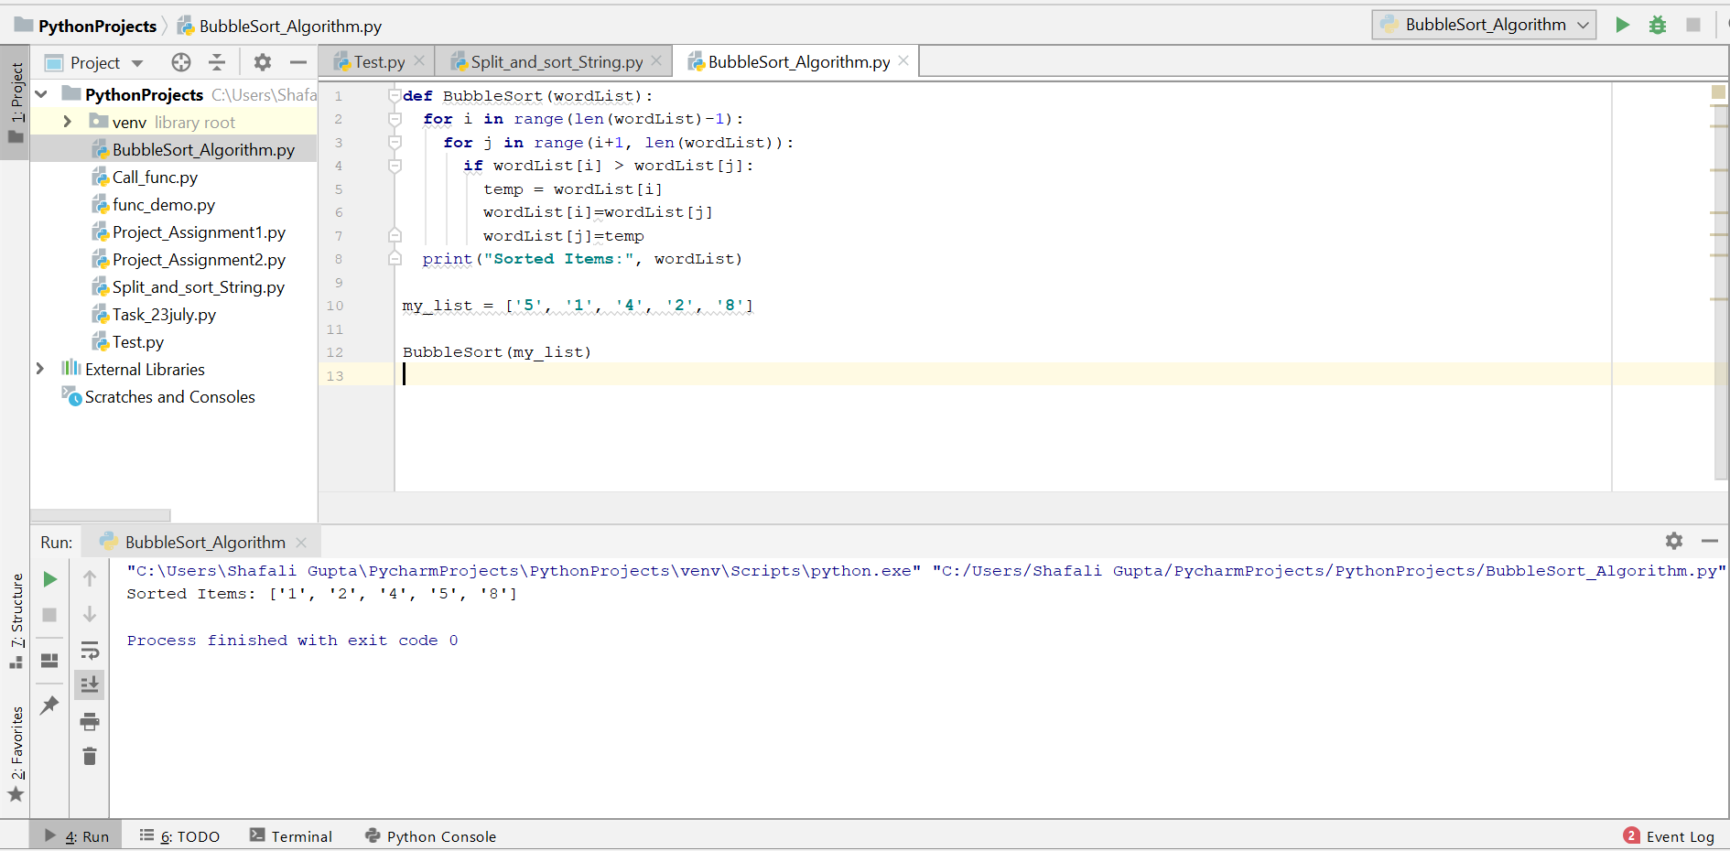

**B) Quick Sort:**

Quicksort is a Divide and Conquer algorithm. It picks an element as pivot and partitions the given array around the picked pivot. The key process in quicksort is partition(). Target of partitions is, given an array and an element x of array as pivot, put x at its correct position in sorted array and put all smaller elements (smaller than x) before x, and put all greater elements (greater than x) after x.

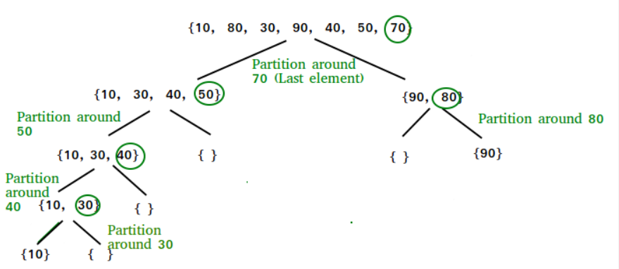

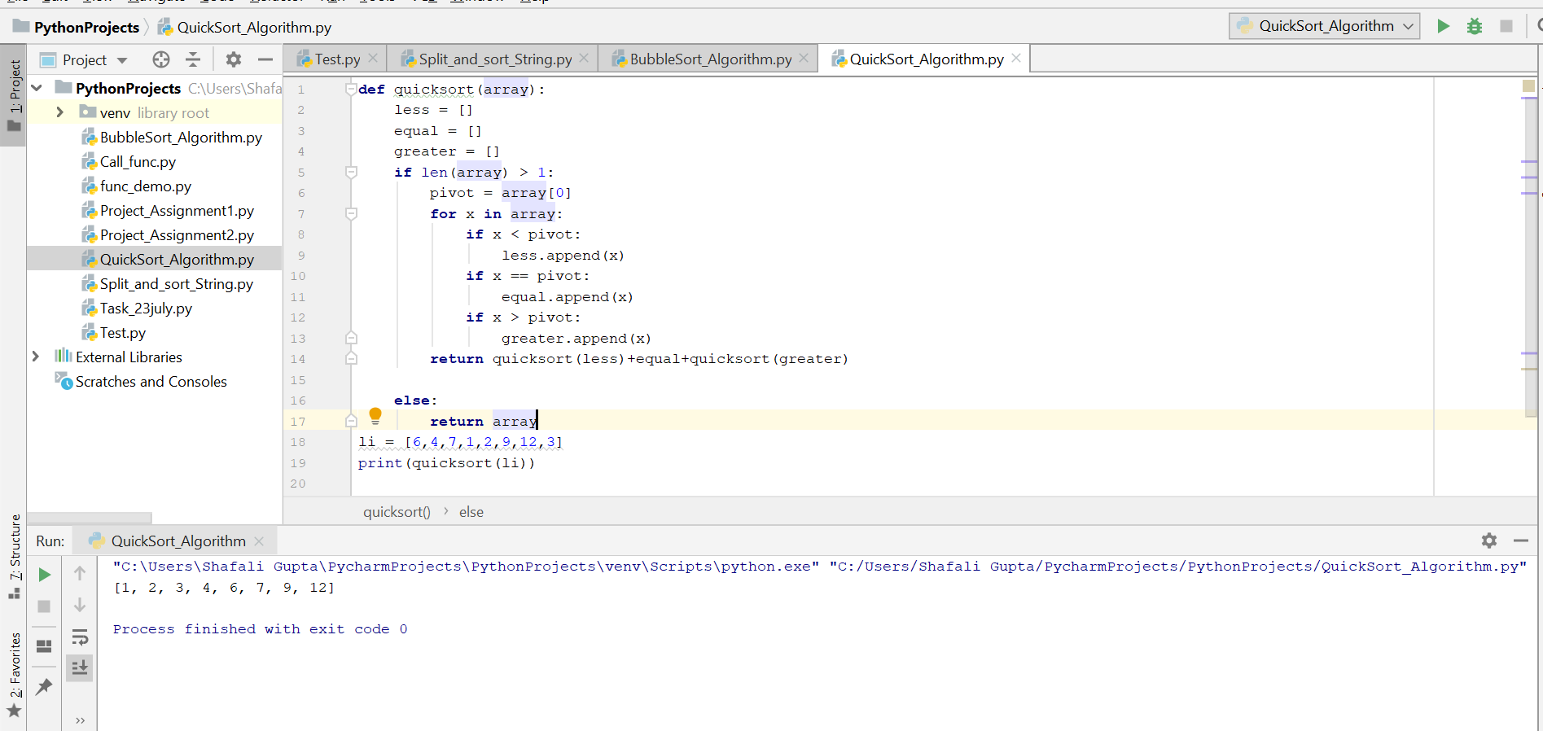

**C) Selection Sort:**

The selection sort algorithm sorts an array by repeatedly finding the minimum element (considering ascending order) from unsorted part and putting it at the beginning. The algorithm maintains two subarrays in a given array.

1) The subarray, which is already sorted.

2) Remaining subarray, which is unsorted.

In every iteration of selection sort, the minimum element (considering ascending order) from the unsorted subarray is picked and moved to the sorted subarray.

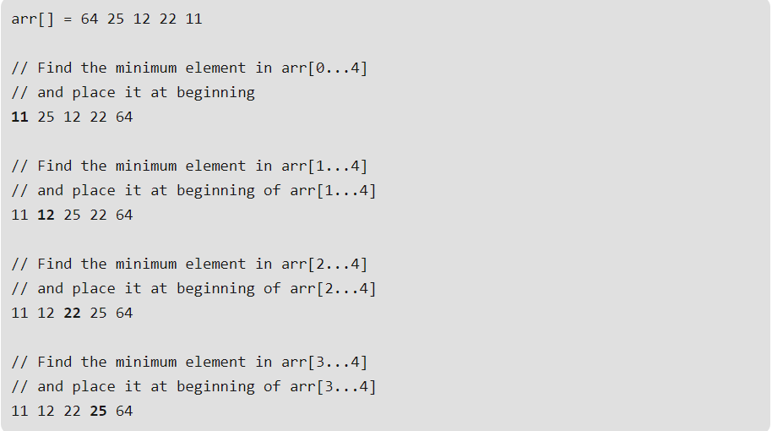

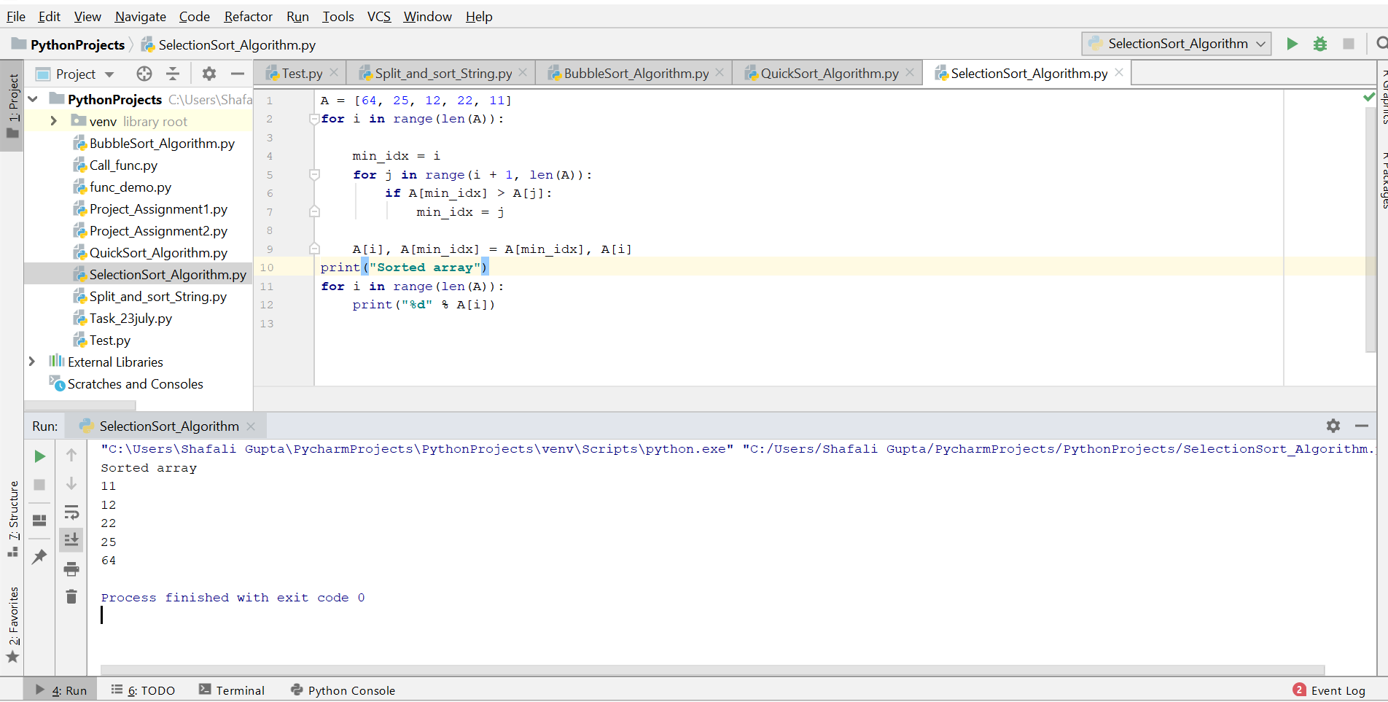

**d) Merge Sort:**

Merge Sort is a Divide and Conquer algorithm. It divides input array in two halves, calls itself for the two halves and then merges the two sorted halves. The merge() function is used for merging two halves.

